**Image Processing**

* Results:
* Original Image
* 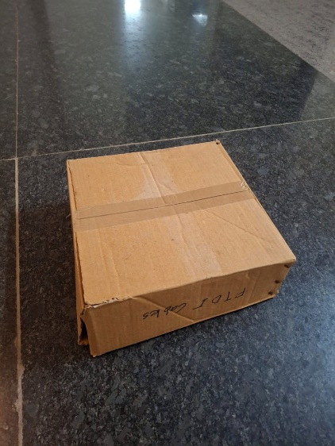
* Gray Scale Image
* 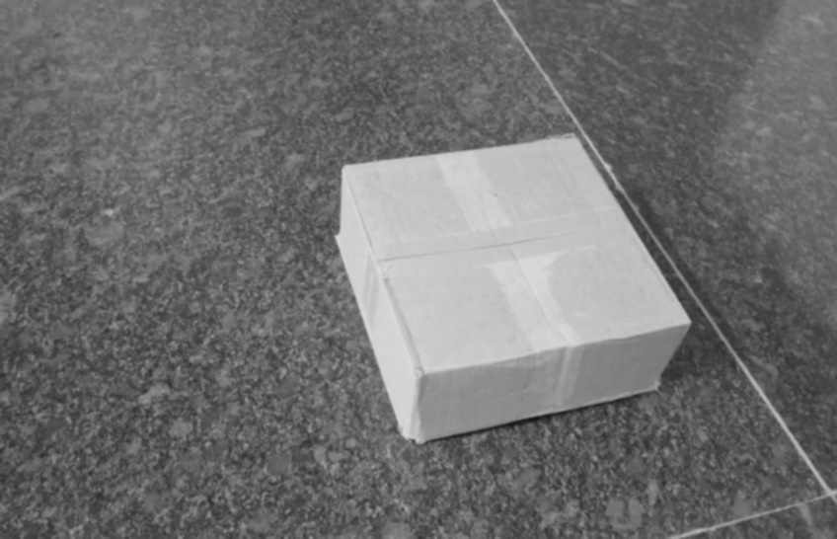
* Edge Detection (Noisy output)
* 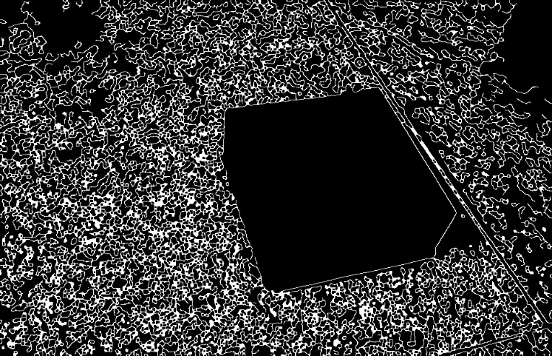
* Masking after converting to HSV color space based on the box colo
* 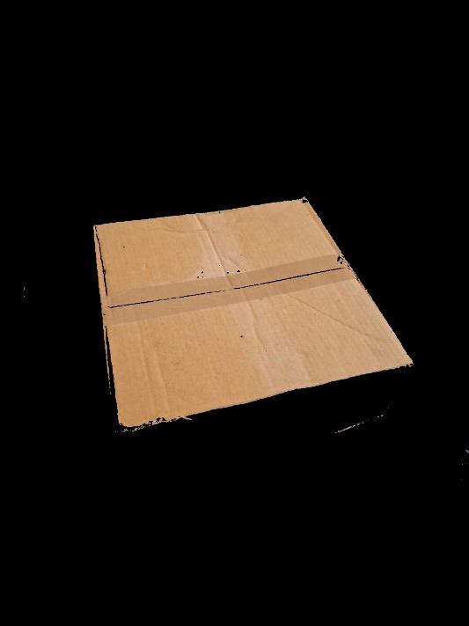
* Edge Detection output on this
* 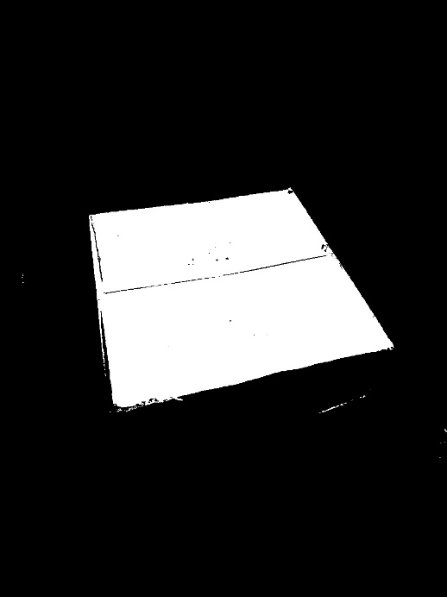

Observation: Post this step I was getting errors and did not have enough time to debug them to extract the coordinates and place sticker. I also tried learning about YOLOv8n and tried implementing it. However because I did not have an appropriate data set I tried, Data augmentation and transfer learning but that did not give any correct results.